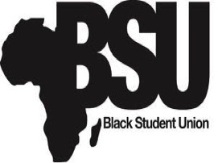
Black Student Union
University of Michigan-Dearborn
4901 Evergreen Rd.
Dearborn, MI 48128
bsu.umd@gmail.com
7th ANNUAL NIGHT OF SOUL PRESS RELEASE
On Thursday February 20, 2014, the Black Student Union at the University of Michigan-Dearborn will be hosting the 7th Annual “Night Of Soul Talent Showcase”. This event will be from 7pm-10pm in the House of Maize in Blue located in the Union. This event will be a concert featuring some of the best talent that Detroit has to offer as well as the university. The show will feature singers, rappers, and poets.
Doors will open at 6:45pm and the show will start promptly at 7:00pm. Performers include Kendrick Hardaway, La’Britney, Keeley Ferguson, Alise King, and more! The event will be hosted by radio/television personality Shorty Da Prince. This event is free and the attire is dress to impress!
For more information or if you have any questions, please email bsu.umd@gmail.com.

Thank You,

Jerel Jones
Black Student Union Marketing Director
University of Michigan-Dearborn
bsu.umd@gmail.com

