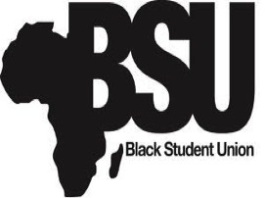
Black Student Union
University of Michigan-Dearborn
4901 Evergreen Rd.
Dearborn, MI 48128
bsu.umd@gmail.com
NIGHT OF SOUL PRESS RELEASE
On Thursday, February 21, 2013, the Black Student Union will be hosting the 6th Annual “Night Of Soul Talent Showcase”. This event will be from 6pm-10pm in the Social Sciences building room 1500 at the University Of Michigan-Dearborn. The show venue will be a large lecture room. “Night of Soul” is a concert styled showcase which features some of the best Detroit talent as well as campus talent. The show will feature singers, poets, rappers, etc.
Hors d'oeuvres will be served from 6:00-6:45pm in the outer corridor of the venue. Doors will open promptly at 6:45 and the show will start at 7:00pm. Performers include Rashad Morgan, Selena Jordan, La’Britney, and many more! This event is FREE to everyone and you are encouraged to bring guests! The attire for this showcase is Dress To Impress!!!

Thank You,
Jerel Jones
Black Student Union Marketing Director
University of Michigan-Dearborn
bsu.umd@gmail.com

